EXP 2
#include <stdio.h> #include <stdlib.h>

int main()
{
FILE *fptr1, *fptr2; char filename[100], c;

printf("Enter the filename to open for reading \n"); scanf("%s", filename);
fptr1 = fopen(filename, "r");if (fptr1 == NULL)
{
printf("Cannot open file %s \n", filename); exit(0);
}

printf("Enter the filename to open for writing \n"); scanf("%s", filename);
fptr2 = fopen(filename, "w");if (fptr2 == NULL)
{
printf("Cannot open file %s \n", filename); exit(0);
}
c = fgetc(fptr1); while (c != EOF)
{
fputc(c, fptr2); c
= fgetc(fptr1);
}
printf("\nContents copied to %s", filename); fclose(fptr1);
fclose(fptr2); return 0;
}

OUTPUT

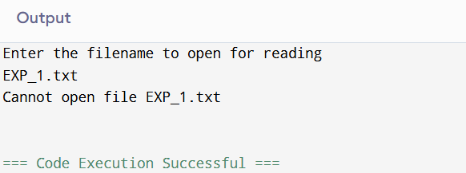
EXP 3
CODE:
#include <stdio.h>int main()
{
int A[100][4];
int i, j, n, total = 0, index, temp;float avg_wt, avg_tat;
printf("Enter number of process: "); scanf("%d", &n);
printf("Enter Burst Time:\n");for (i
= 0; i < n; i++) {
printf("P%d: ", i + 1); scanf("%d", &A[i][1]); A[i][0] = i + 1;
}
for (i = 0; i < n; i++) {
index = i;

for (j = i + 1; j < n; j++)
if (A[j][1] < A[index][1]) index = j;
temp = A[i][1]; A[i][1] =
A[index][1];A[index][1]
= temp;

temp = A[i][0]; A[i][0] =
A[index][0];A[index][0]
= temp;
}
A[0][2] = 0;
for (i = 1; i < n; i++) {
A[i][2] = 0;
for (j = 0; j < i; j++)
A[i][2] += A[j][1];
total += A[i][2];
}
avg_wt = (float)total / n; total = 0;
printf("P BT WT TAT\n");

for (i = 0; i < n; i++) {
A[i][3] = A[i][1] + A[i][2];
total += A[i][3];
printf("P%d %d %d %d\n", A[i][0],A[i][1],
A[i][2], A[i][3]);
}

avg_tat = (float)total / n;
printf("Average Waiting Time= %f", avg_wt); printf("\nAverage Turnaround Time= %f", avg_tat);

OUTPUT:

